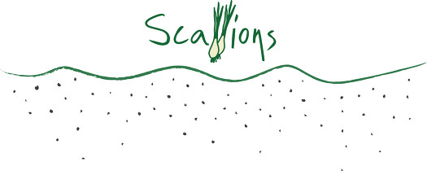

Thursday, September 22 from 5-9 pm Scallions Restaurant at 44 Lake Avenue, Saratoga Springs will be donating 10 percent of all sales to the Friends of the Library.

So enjoy a delicious meal out and support the Friends of the Library\*

Reservations encouraged but not required. Call Scallions at 518.584.0192

\*Our mission is to support the programs, staff, and facilities of the public library. We are a not-for-profit community organization dedicated to providing funds and volunteer services that the library itself may be unable to provide.

Dine at Scallions and benefit the Friends of the Library!!

Friends of Library